Project Design Phase-II
Data Flow Diagram & User Stories

Date | 29 September 2026
Team ID | SWTID-2026-2169
Project Name | Import Data using Transform Map
Maximum Marks | 4 Marks

Data Flow Diagrams:
A Data Flow Diagram (DFD) is a traditional visual representation of the information flows within a system. A neat and clear DFD can depict the right amount of the system requirement graphically. It shows how data enters and leaves the system, what changes the information, and where data is stored.
DFD: Import Data using Transform Map
The administrator uploads an Excel/CSV file, which is registered as a Data Source and loaded into the Import Set (staging) table. A Transform Map then maps the source fields to the target table fields using field mapping and a coalesce field. When the transform runs, on Before / on After scripts validate the data and the clean records are stored in the target table. The import log and transform history are shared with the administrator, and end users view the final data through dashboards and reports.
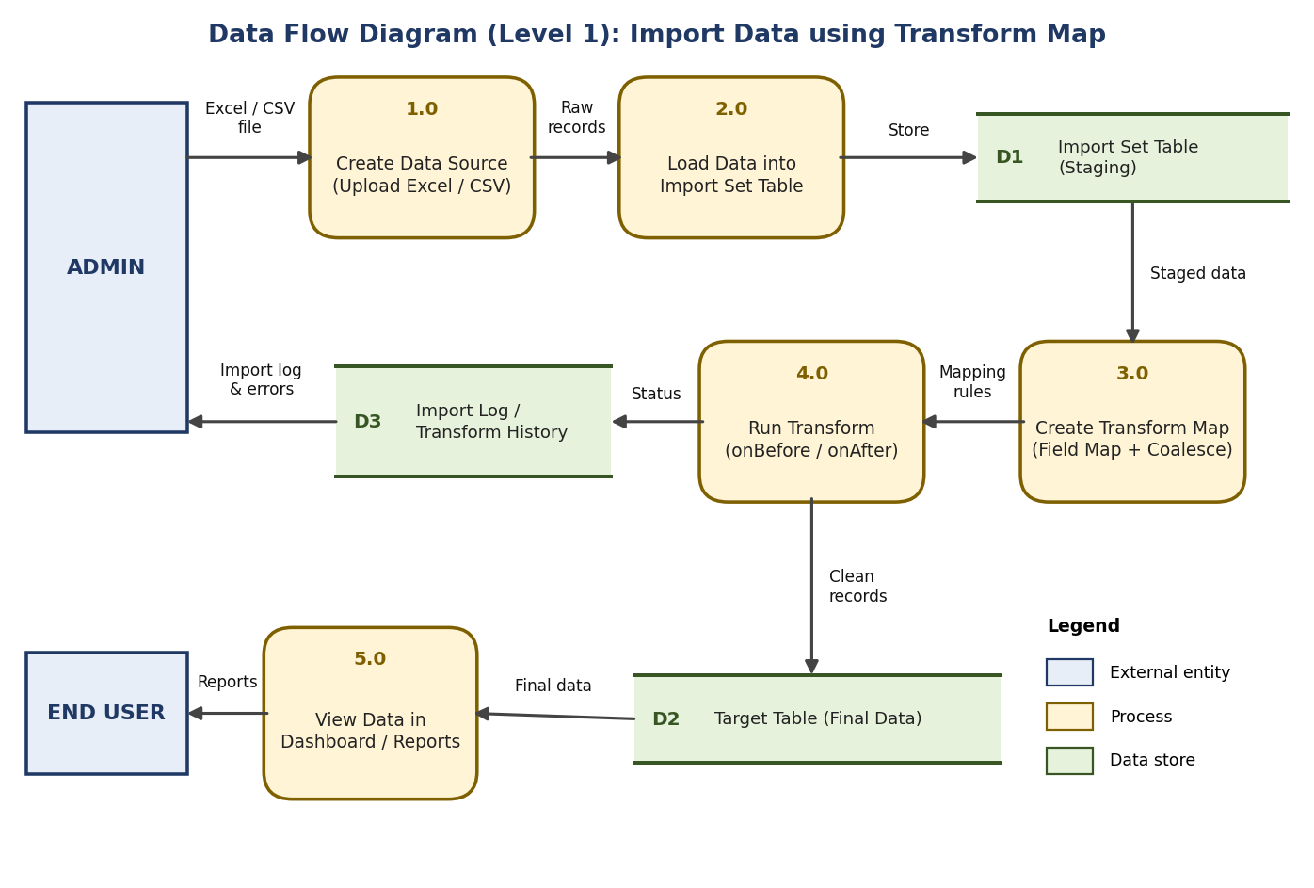
Figure 1: Data Flow Diagram (Level 1) for Import Data using Transform Map
User Stories
The user stories for the Import Data using Transform Map application are listed below.
User Type | Functional Requirement (Epic) | User Story Number | User Story / Task | Acceptance criteria | Priority | Release
Admin | Data Source | USN-1 | As an admin, I can upload an Excel / CSV file so that the data can be imported into the application. | I can upload the file and see it attached to the data source | High | Sprint-1
 |  | USN-2 | As an admin, I can create a Data Source record that points to the uploaded file. | I can create the data source and preview the file data | High | Sprint-1
 | Import Set | USN-3 | As an admin, I can load the file data into an Import Set (staging) table. | I can see the loaded records in the import set table | High | Sprint-1
 | Transform Map | USN-4 | As an admin, I can create a Transform Map between the import set (source) table and the target table. | I can see the transform map linked to the correct source and target tables | High | Sprint-1
 |  | USN-5 | As an admin, I can map source fields to target fields in the Transform Map. | Each source field is mapped to the right target field | High | Sprint-1
 |  | USN-6 | As an admin, I can set a coalesce field so that duplicate records are updated instead of created again. | Existing records are updated and no duplicates are created | Medium | Sprint-2
 | Run Transform | USN-7 | As an admin, I can run the transform and use onBefore / onAfter scripts to validate and clean the data. | Valid data is loaded into the target table after the transform completes | High | Sprint-2
 | Validation & Logs | USN-8 | As an admin, I can view the import log and transform history to check inserted, updated and skipped records. | I can see the record counts and error details for each import | Medium | Sprint-2
Customer (Mobile user) | Dashboard | USN-9 | As a user, I can view the imported data in the dashboard on my mobile device. | I can log in and see the imported records correctly | Medium | Sprint-3
Customer (Web user) | Dashboard | USN-10 | As a user, I can view the imported data in reports on the web application. | I can log in and view the imported data in reports | Medium | Sprint-3
Customer Care Executive | Data Access | USN-11 | As a customer care executive, I can search the imported records to help customers with their queries. | I can search and view the required record details | Low | Sprint-3

